Contents

Task 03 1

Code 1

Output 1

Task 04 1

Code 1

Output 2

Task 05 2

Code 2

Output 3

Task 06 3

Code 3

Output 3

Task 07 4

Code 4

Output 4

# Task 03

## Code

clc

clear all

close all

a=5^2

b=(5+3)/(5*6)

c=sqrt(4+6^3)

d=9+6/12+7*5^(3+2)

e=1+5*3/6^2 + 2^(2-4)*1/5.5

## Output

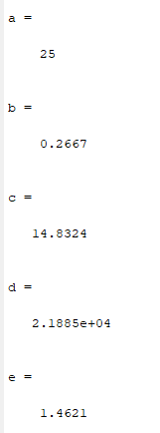

# Task 04

## Code

clc

clear all

close all

% a.

r = 5;

area_a = pi*r^2

% b.

r = 10;

area_b = 4*pi*r^2

% c.

r = 2;

area_c = 4/3*pi*r^3

## Output

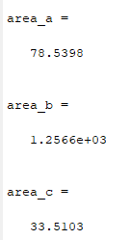

# Task 05

## Code

% a.

edge = 5;

area = edge^2

% b

edge = 10;

sArea = 6 * edge^2

% c

edge = 12;

vol = edge^3

## Output

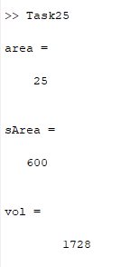

# Task 06

## Code

clc

clear all

% a)

rs=10;

h=15;

d=1;

r=d/2;

Vol_barBell_A=2*(((4/3)*pi*rs^3))+(pi*r^3*h)

% b)

Vol_barBell_B=2*4*pi*(rs^2) + 2*pi*r*h

## Output

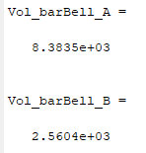

# Task 07

## Code

clc

clear all

P=220;

n=2;

V=1;

a=5.536;

b=0.03049;

R=0.08314472;

T1=(P*V)/(n*R)

t1=(n^2*a)/(V^2);

t2=(V-(n*b));

T2=((P+t1)*t2)/(n*R)

## Output

